

**Argentis Consulting**



**Apparel & Footwear**

DTW - Data Migration of Cost Sheets and BOM



### [www.sapapparel.com](http://www.sapapparel.com/)

INDEX

1.1

1.2

INTRODUCTION 3

TEMPLATES 3

* + 1. Templates related to Cost Sheet 3
       1. Template: ARGNS_COST_SHEET - ARGNS_COST_SHEET 3
       2. Template: ARGNS_CS_MATERIALS - ARGNS_CS_MATERIALS 4
       3. Template: ARGNS_CS_OPERATIONS - ARGNS_CS_OPERATIONS 5
       4. Template: ARGNS_CS_SUB_OPER - ARGNS_CS_SUB_OPER 6
       5. Template: ARGNS_CS_SCHEMAS - ARGNS_CS_SCHEMAS 6
    2. Templates related to BOM 7
       1. OITT - ARGNS_ProductTrees 7
       2. ITT1 - ARGNS_ProductTrees_Lines 7
  1. DATAIMPORT PROCESS 8
     1. Excel Preparation 8
        1. Create the COST_SHEET 8
        2. Create the COST_SHEET_Material 9
        3. Create the COST_SHEET_Operation 10
        4. Create the ARGNS_CS_SUB_OPER - ARGNS_CS_SUB_OPER 11
        5. Create the ARGNS_CS_SCHEMAS - ARGNS_CS_SCHEMAS 12
        6. Create the OITT - ARGNS_ProductTrees 13
        7. Create the ITT1 - ARGNS_ProductTrees_Lines 13
     2. CSV files import trough DTW– Cost Sheet…………………………………… 14
     3. CSV files import trough DTW– Bill of Materials 20

2



## INTRODUCTION

Este documento contiene la información necesaria para preparar y ejecutar la migración de datos para la hoja de costes, lista de materiales utilizando la herramienta DTW. This document contains the necessary information to prepare and execute data migration for Cost sheet, BOM using the DTW tool.

## TEMPLATES

1.2.1 Templatesrelated to Cost Sheet

To import data related to Cost sheet the following Excel templates need to be completed:

1. ARGNS_COST_SHEET - ARGNS_COST_SHEET
2. ARGNS_CS_MATERIALS - ARGNS_CS_MATERIALS
3. ARGNS_CS_OPERATIONS - ARGNS_CS_OPERATIONS
4. ARGNS_CS_SUB_OPER - ARGNS_CS_SUB_OPER
5. ARGNS_CS_SCHEMAS - ARGNS_CS_SCHEMAS
   * + 1. Template: ARGNS_COST_SHEET - ARGNS_COST_SHEET

Esta es la plantilla que contiene la información general para cada hoja de costos en un nivel de encabezado.

Los campos relevantes en esta plantilla son:

1. Code: SAP Internal Code. Este código es una secuencia a partir de 1. Debe ser único
2. Name: Cost Sheet Code. Esto debe ser el mismo que el código del modelo
3. U_ModCode: Style Code. Este código DEBE ser único y debe corresponder a un código único (SAP Internal Code)
4. U_Description: Descripción de la hoja de costes
5. U_Selected: Hoja de costes seleccionada o no (Valor por defecto: N)
6. U_PurchPrice: Necesidad de mencionar el precio de compra del artículo
7. U_TMaterials: Es necesario mencionar el costo total del material
8. U_TOperations: Es necesario mencionar el costo total de las operaciones
9. U_IndrCost: Es necesario mencionar el costo indirecto total
10. U_TCost: Necesidad de mencionar el costo total
11. U_CostPercent: Need to mention the cost mark up %
12. U_SlsPercent: Need to mention the sales cost mark up %
13. U_StrFactor: Need to mention the store factor. The suggested price will be multiplied by the factoring value
14. U_FPrice: Need to mention the final price which can be copied to the price list
15. U_OTCode: Operation Template Code
16. U_SchCode: Scheme code
17. U_Vendor: Vendor Code
18. U_VName: Vendor Name
19. U_ContPerson: Contact Person
20. U_CSSERDate: Exchange rate date
21. U_Currency: Need to mention the currecy code

3



Notes:

1. A code must be used for each of the fields that are related to other objects. i.e. For Material,Operation, Sub-operation, Schemas.
2. Operation template, Cost schema must exist previously in SAP otherwise errors might come up during the data import process.
   * + 1. Template: ARGNS_CS_MATERIALS - ARGNS_CS_MATERIALS

This template holds the material details related to each cost sheet, this is where the all the raw/semi-finished materials need to be mentioned.

The relevant fields in this template are:

1. ParentKey: This is the SAP internal code defined in the code field of the ARGNS_COST_SHEET - ARGNS_COST_SHEET template.
2. LineNum: Leave blank. This field is automatically completed by DTW during the import process.
3. Code: This is the SAP internal code defined in the code field of the ARGNS_COST_SHEET - ARGNS_COST_SHEET template. Same as ParentKey
4. U_ItemCode: Item code (This should be the raw/semi finished item code)
5. U_ItemName: Item name
6. U_Quantity: Need to mention the item quantity
7. U_UoM: Unit of measurement
8. U_Whse: Warehouse code
9. U_IssueMth: Item Issue methord
10. U_PList: Price list code
11. U_UPrice: Unit price
12. U_Total: Total price
13. U_Comments: Comments
14. U_TreeType: Treetype, P for Prepack and N for raw material
15. U_PVendor: Preffered vendor code
16. U_OcrCode: Cost center code
17. U_Currency: Currency code
18. U_ItmLinkO: Link operation code
19. U_CxT: Consumed by size
20. U_CxS: Consumed by semifinished
21. U_CxC: Consumed by color
22. U_CxGT: Consumed by size group
23. U_VRM: Vendor raw materials
24. U_PattCode: Pattern code
25. U_PattQty: Pattern quantity

4





Notes:

1. The ParentKey and Code will always have the same value and it must exist in the ARGNS_COST_SHEET -

ARGNS_COST_SHEET

1. Warehouse, Prcie List code must exist in the SAP otherwise errors might come up during the data import process.
   * + 1. Template: ARGNS_CS_OPERATIONS - ARGNS_CS_OPERATIONS This template holds the details of operation and sub-operation.

The relevant fields in this template are:

1. ParentKey: This is the SAP internal code defined in the code field of the the ARGNS_COST_SHEET -

ARGNS_COST_SHEET template.

1. LineNum: Leave blank. This field is automatically completed by DTW during the import process.
2. Code: This is the SAP internal code defined in the code field of the ARGNS_COST_SHEET - ARGNS_COST_SHEET template. Same as ParentKey
3. U_ItemCode: Operation code (Defined in the Operation template)
4. U_ItemName: Operation name (Defined in the Operation template)
5. U_Quantity: Operation quantity (Defined in the Operation template)
6. U_UoM: Unit of measurement
7. U_PList: Price list code (Defined in the Operation template)
8. U_Price: Operation price (Defined in the Operation template)
9. U_Currency: Currency code (Defined in the Operation template)
10. U_SAM: Sandard allowed minutes (Defined in the Operation template)
11. U_Seconds: Seconds (Defined in the Operation template)
12. U_ResCode: Resouce Code (Defined in the Operation template)
13. U_SOTCode: Sub-operation template code defined in the Notes:
14. The ParentKey and Code will always have the same value and it must exist in the ARGNS_COST_SHEET -

ARGNS_COST_SHEET.

1. Operation template, Sub-Operation template must exist previously in SAP otherwise errors might come up during the data import process.

5





* + - 1. Template: ARGNS_CS_SUB_OPER - ARGNS_CS_SUB_OPER

This template holds the details of sub-operation which is linked with operation temaplate The relevant fields in this template are:

1. ParentKey: This is the SAP internal code defined in the code field of the the ARGNS_COST_SHEET -

ARGNS_COST_SHEET template.

1. LineNum: Leave blank. This field is automatically completed by DTW during the import process.
2. Code: This is the SAP internal code defined in the code field of the ARGNS_COST_SHEET - ARGNS_COST_SHEET template. Same as ParentKey.
3. U_SOTCode: Sub-operation template code
4. U_SOCode: Sub operation code
5. U_SODesc: Sub operation description
6. U_STime: Estimated Time in seconds
7. U_Order: Sub operation order

Notes:

1. The ParentKey and Code will always have the same value and it must exist in the ARGNS_COST_SHEET -

ARGNS_COST_SHEET.

1. Sub-Operation template must exist previously in SAP otherwise errors might come up during the data import process.
   * + 1. Template: ARGNS_CS_SCHEMAS - ARGNS_CS_SCHEMAS

This template holds the details of schemas and associate indirect costs. The relevant fields in this template are:

1. ParentKey: This is the SAP internal code defined in the code field of the the ARGNS_COST_SHEET -

ARGNS_COST_SHEET template.

1. LineNum: Leave blank. This field is automatically completed by DTW during the import process.
2. Code: This is the SAP internal code defined in the code field of the ARGNS_COST_SHEET - ARGNS_COST_SHEET template. Same as ParentKey.
3. U_SchCode: Cost Schema Code (Defined in the Cost Schema)
4. U_ItemCode: Cost schema item code (Defined in the Cost Schema)
5. U_ItemName: Cost schema item name (Defined in the Cost Schema)
6. U_Amount: Item cost (Defined in the Cost Schema)
7. U_AplicTo: Applied to (Defined in the Cost Schema)
8. U_Currency: Currency code (Defined in the Cost Schema)
9. U_PList: Price list code (Defined in the Cost Schema)

Notes:

1. The ParentKey and Code will always have the same value and it must exist in the ARGNS_COST_SHEET -

ARGNS_COST_SHEET.

1. Cost Schema must exist previously in SAP otherwise errors might come up during the data import process.

6





* + 1. Templates related to BOM

To import data related to BOM the following Excel templates need to be completed:

* + - 1. OITT - ARGNS_ProductTrees
      2. ITT1 - ARGNS_ProductTrees_Lines
      3. OITT - ARGNS_ProductTrees

1. TreeCode: Parent Item code (This should be generated SKU code)
2. TreeType: BOM type
3. Quantity: Quantity
4. DistributionRule: Cost Center Code

Notes:

1. For specific style, SKU should be generated before creating BOM.
2. Cost sheet must be created for the style and U_Selected field must be ‘Y’ in ARGNS_MODEL_CS - ARGNS_MODEL_CS template before creating BOM otherwise errors might come up during the data import process.
   * + 1. ITT1 - ARGNS_ProductTrees_Lines
3. ParentKey: Parent Item code defined in the code field of the the TreeCode field in OITT - ARGNS_ProductTrees template.
4. LineNum: Leave blank. This field is automatically completed by DTW during the import process.
5. ItemCode: Child item, Operation Code.
6. Quantity: Child Item quantity.
7. Warehouse: Warehouse code.
8. Price: Unit price.
9. Currency: Currency code.
10. IssueMethod: Issue method (M-Manual, B-Backflash).
11. ParentItem: Same as the TreeCode field in OITT - ARGNS_ProductTrees template.
12. PriceList: Price list code.
13. DistributionRule: Cost center code same as defined in the OITT - ARGNS_ProductTrees template.
14. U_ARGNS_Operation: Mention ‘Y’ if item type is operation and select ‘N’ if item type is raw/semi-finished. 13: U_ARGNS_LinkOper: Mention linked operation code where U_ARGNS_Operation field is ‘N’.
15. U_ARGNS_SAM: Standard allowed minutes.
16. U_ARGNS_SEC: Standard seconds
17. U_ARGNS_ResCode: Resource Code

7



Notes:

1. The ParentKey and ParentItem will always have the same value and it must exist in the OITT - ARGNS_ProductTrees template.
2. Cost Schema must exist previously in SAP otherwise errors might come up during the data import process.

## DATA IMPORT PROCESS-

* + 1. Excel Preparation
       1. Create the COST_SHEET

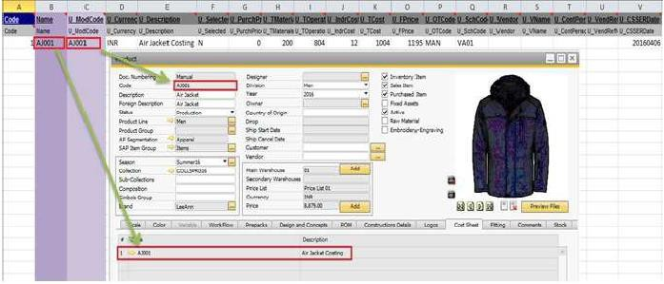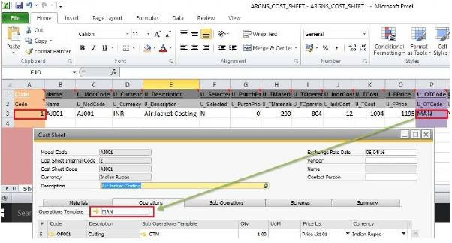

8



* + - 1. Create the COST_SHEET_Material

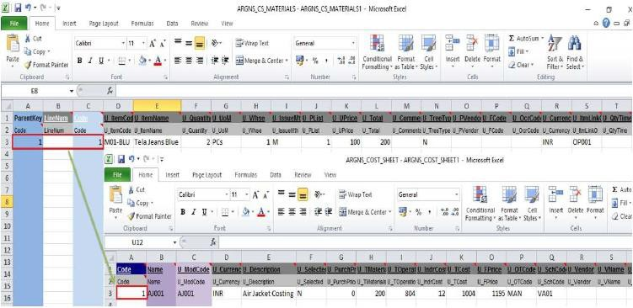

9



* + - 1. Create the COST_SHEET_Operation

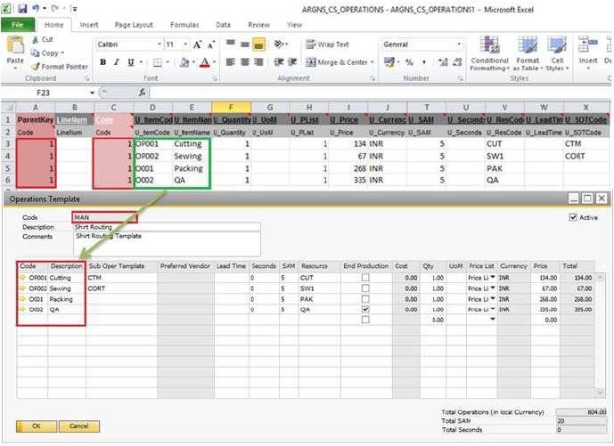

10



* + - 1. Create the ARGNS_CS_SUB_OPER - ARGNS_CS_SUB_OPER

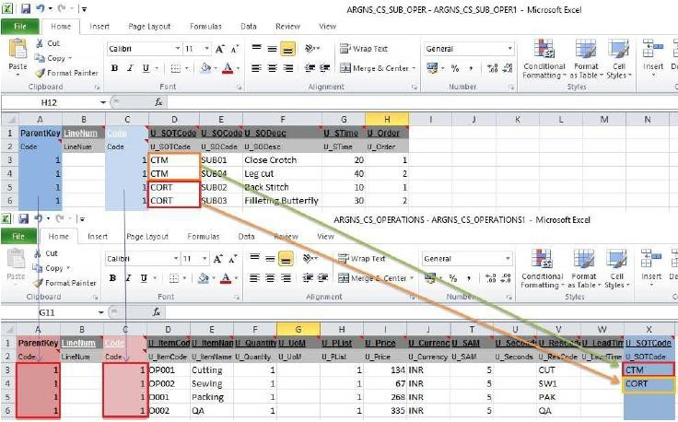

11



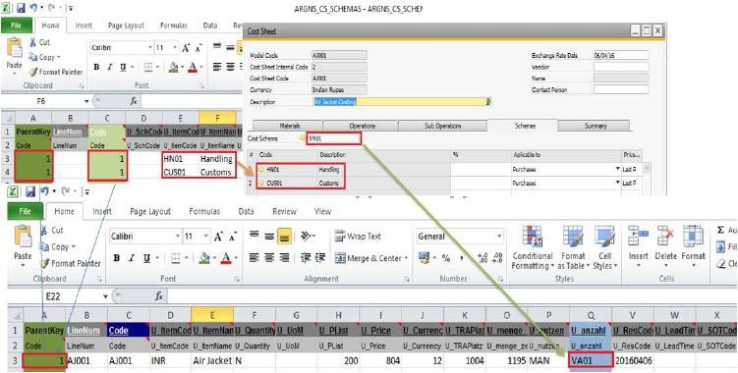

12



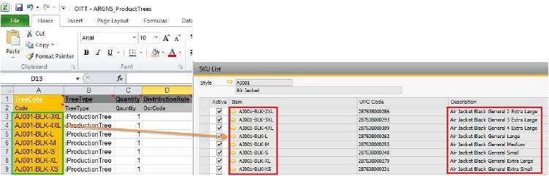

1.3.1.7 Create the ITT1 - ARGNS_ProductTrees_Lines

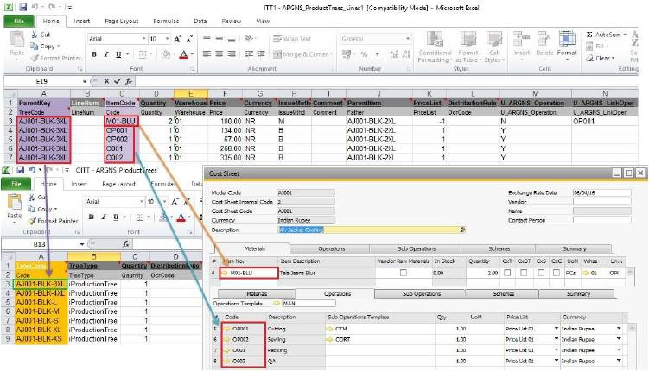

13



* + 1. CSVfiles import trough DTW–Cost Sheet
       1. Click on the “Import” button to start the Data import wizard
       2. Select **Master data** as the data type for importing Cost Sheets

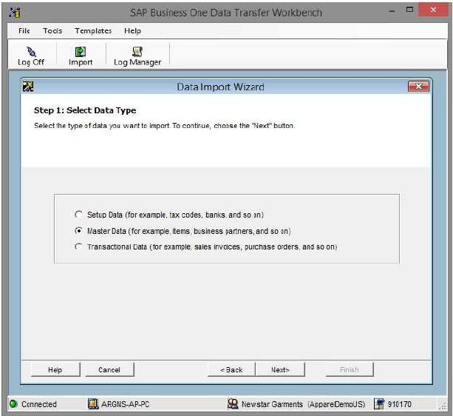

14



* + - 1. Select **Add new data** as the operation type (Please note that if you are working with already existing styles, then select the **Update existing data** option or the **Add new data and Update existing data** if

you are going to be updating data and loading new data all in the same process).

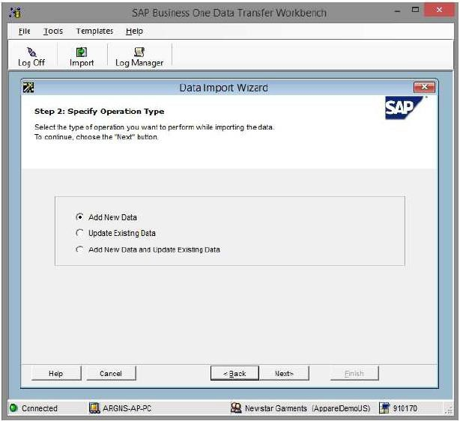

15



* + - 1. Search and select the UDO_ARGNS_COST_SHEET business object under the following path: User Defined Data > Objects (UDO) > UDO_ARGNS_COST_SHEET .

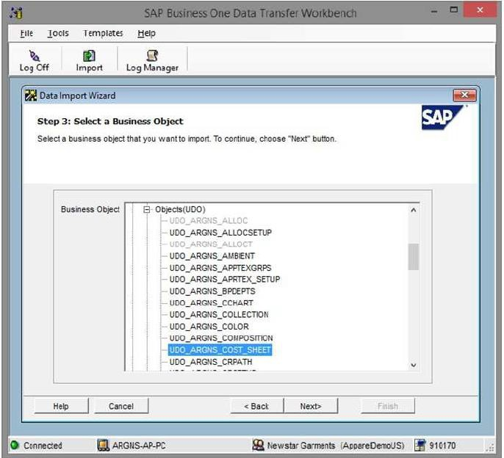

16





* + - 1. Select the templates corresponding to each Cost_sheet object. Please note that there are templates which are not necessary to have them filled with data but that must be selected as required by DTW.

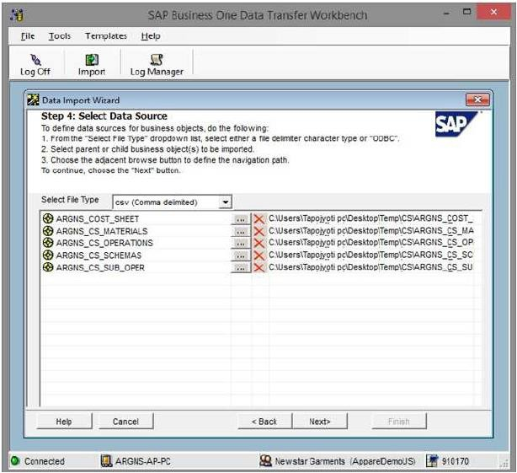

17





* + - 1. Map Cost_Sheet Object fields. This is a confirmation screen for the data mapping.

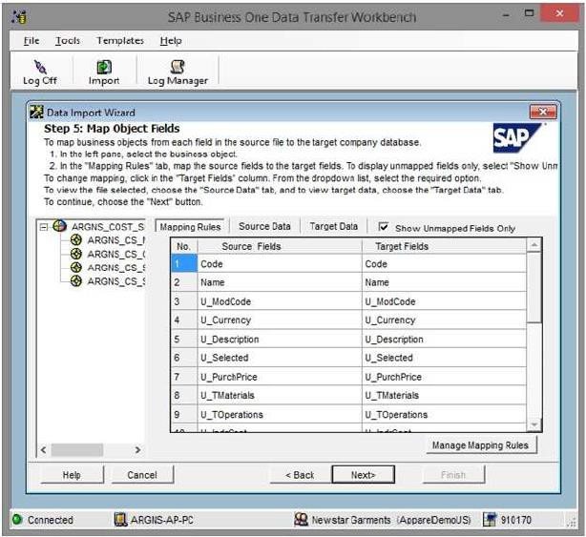

18





* + - 1. Define error handling. It is usually recommended to select the last option to prevent from processing the entire file if a certain number of errors are found. In this step it is usually recommended to run

the simulation process (by clicking the Run Simulation button) to get a preview of the data import result.

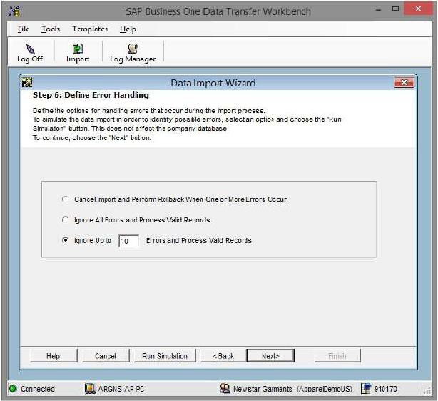

* + - 1. Start importing data. If no errors were found in the simulation process, click on the Import button to start the actual data import process. Please not that this does not guarantees that the data imported is accurate and it must be checked within SAP to make sure that everything is being loaded the way it should.

19





* + 1. CSVfiles import trough DTW– Bill of materials
       1. Click on the “Import” button to start the Data import wizard
       2. Select Transactional data as the data type for importing BOMs.

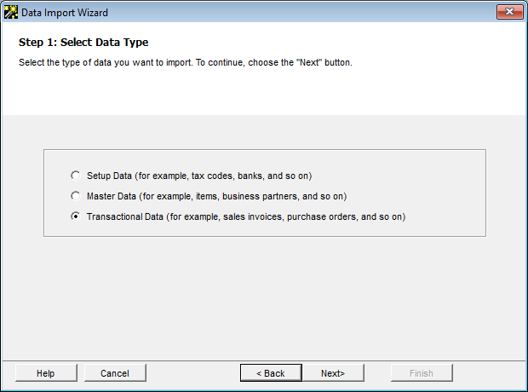

20



* + - 1. Select Add new data as the operation type (Please note that if you are working with already existing BOM, then select the Update existing data option or the Add new data and Update existing data if

you are going to be updating data and loading new data all in the same process).



21



* + - 1. Search and select the Production business object under the following path: Production > Bill Of Materials

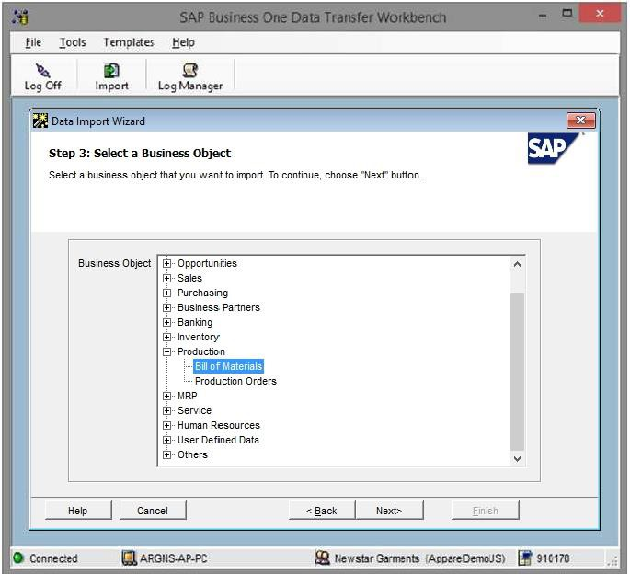

22



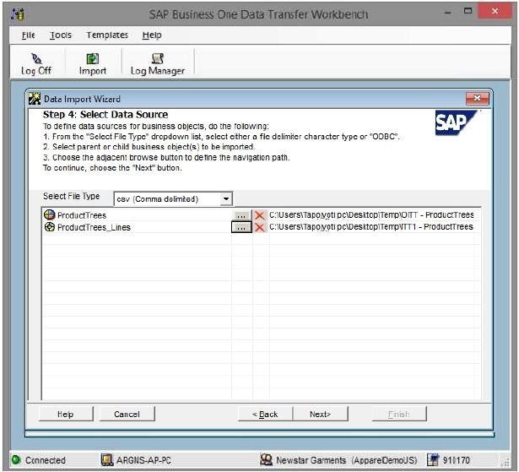

23



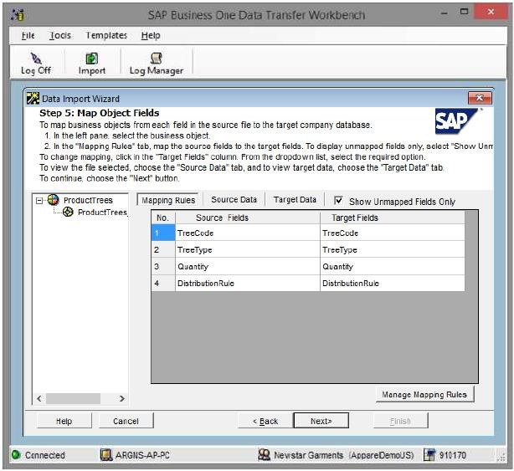

24





* + - * 1. Define error handling. It is usually recommended to select the last option to prevent from processing the entire file if a certain number of errors are found. In this step it is usually recommended to run

the simulation process (by clicking the Run Simulation button) to get a preview of the data import result.



* + - * 1. Start importing data. If no errors were found in the simulation process, click on the Import button to start the actual data import process. Please not that this does not guarantees that the data imported is accurate and it must be checked within SAP to make sure that everything is being loaded the way it should.

25







**Argentis Consulting** is dedicated to the development, distribution

# and support of recognized certified solutions for SAP Business One,

as an SSP (Software Solution Provider) with a Gold Partner status.

### CONTACT INFORMATION

**USA**

9744 NW 45th Lane Doral, FL 33178

[info@argentisconsulting.com](mailto:info@argentisconsulting.com)

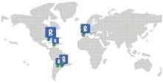

**CARIBEAN**

City View Plaza – Suite 301 48 Road 165

Guaynabo, PR. 00968 Puerto Rico

[caribe@argentisconsulting.com](mailto:caribe@argentisconsulting.com)

**ARGENTINA**

Ávila y Zarate 2048

Cerro de la Rosas, Córdoba, CP 5009

Córdoba - Argentina [info@argentisconsulting.com](mailto:info@argentisconsulting.com)

**SPAIN**

C/ Juan Bravo N° 3 A 28006

Phone: (+34) 91 123 7263

Madrid - Spain [info@argentisconsulting.com](mailto:info@argentisconsulting.com)

[**www.argentisconsulting.com**](http://www.argentisconsulting.com/)

